4.5 Derivatives & the Shape of a Graph

Increasing/Decreasing:

General Idea:
Identify the intervals on which the function pictured below is increasing, decreasing, and constant.
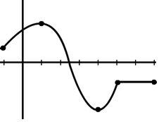
-1
1
4
5
7

This function is increasing on the intervals.

This function is decreasing on the interval .

This function is constant on the interval .

Note: It would also be correct to say the function is increasing on , decreasing on , and constant on . We will have a class agreement that we will always use open intervals when describing these properties.

We notice that at points where the function is decreasing the slopes of the tangent lines to those points are negative. Similarly, at points where the function is increasing the slopes of the tangent lines to those points are positive. We can also see this in the diagram below, and this observation is summarized by the following theorem.

Decreasing = negative slopes | Increasing = positive slopes
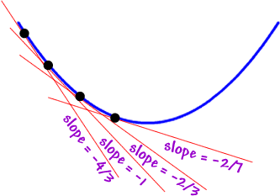 | 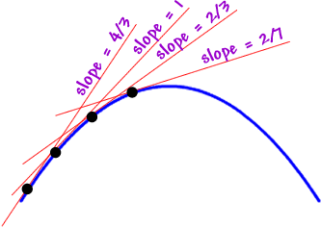

Theorem: Let f be a function that is continuous and differentiable on .
- If for every value of x in , then f is increasing on.
- If for every value of x in , then f is decreasing on.

Note: A proof of this theorem requires the Mean Value Theorem. A proof is provided in the lecture notes.
Proof of (i): (A proof of ii is similar to the following) (NOT DONE IN CLASS)

Suppose we know that f is continuous on , is differentiable on , and for every x in .
Let’s assume that f is not an increasing function on . Then, there exists x-values j and k in such that , but . Since f satisfies the conditions of the MVT we know that there must exist a c in such that . However, since & this means that & which implies that . This is a contradiction because for every x in . Therefore, f must be increasing on .

Example 1: Determine on what intervals is increasing and decreasing.

We calculate that . To make it easier to see when we will find when .

Clearly .
We set up the following number line and using test values we find when the derivative is positive and negative.

$$-2$$
$$+$$
$$-$$
$$+$$
$$0$$

Based on the number line above we conclude that:
is increasing on
is decreasing on

Question: In the example above what would you expect is happening on the graph of the function when and ?

Answer: We would probably expect these x-values to be locations of a local maximum and local minimum values. The next theorem makes this idea precise.

Theorem (The First Derivative Test): Suppose that c is a critical number of a continuous function f.
- If changes from positive to negative at c, then f has a local maximum at c.
- If changes from negative to positive at c, then f has a local minimum at c.
- If does not change (positive on both sides of c or negative on both sides of c) at c, then f has no local maximum or minimum at c.

Example 2: Determine on what intervals is increasing and decreasing and state all local extrema of the graph.

We calculate that and want to find critical values.
is never undefined.
$$2$$
$$-$$
$$+$$
$$MIN$$

Based on the number line we conclude that:

is increasing on . has a local minimum of .
is decreasing on . has no local maximum.

Example 3: Suppose is a function where . Find the intervals on which f is increasing and decreasing. Find the x-value(s) at where all local extrema occur.

We need to find all critical values.
is never undefined.
$$-2$$
$$-5$$
$$2$$
$$+$$
$$+$$
$$-$$
$$+$$
$$MAX$$
$$MIN$$

Based on the number line we conclude that:

is increasing on . has a local minimum at .
is decreasing on . has a local maximum at

Example 4: Determine on what intervals is increasing and decreasing and state all local extrema of the graph.

We calculate that and want to find critical values.
is undefined for .

Of all of these values only is in the domain of , so is our only critical value.
$$-$$
$$+$$
$$MIN$$

Based on the number line we conclude that:

is increasing on . has a local minimum of .
is decreasing on . has no local maximum.

Concavity:
Definition: If f is differentiable on an open interval, then f is said to be

- concave up on the open interval if is increasing on the open interval.

- concave down on the open interval if is decreasing on the open interval.

Concave down = decreasing slopes of tangents | Concave up = increasing slopes of tangents
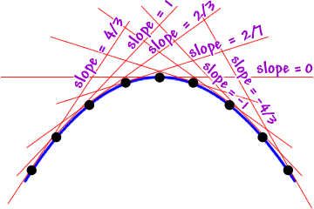 | 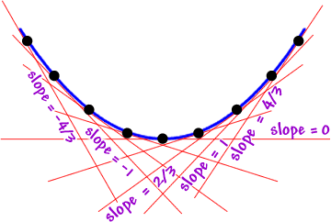
This idea leads to the following theorem.
Theorem (Concavity Test):
- If for all x in I, then the graph of f is concave upward on I.
- If for all x in I, then the graph of f is concave downward on I.

Example 5: Find the intervals where Find the intervals where is concave up/down.

We calculate that:

We want to know when and when . So, we will use the test point method (Note: the same method was used to determine where a function is increasing/decreasing).

is never undefined.
$$2$$
$$0$$
$$+$$
$$-$$
$$+$$

Based on the number line we conclude that:

is concave up on .
is concave down on .

Question: In Example 5, at what points did the concavity of the function change?

The concavity seems to change at x values of 0 and 2. We note that and .
So, the concavity of the graph changes at the points and .
Note: These are ordered pairs. They do NOT represent interval notation!

Definition: If f is a continuous function on an open interval containing the point P, and if f changes its concavity at the point at P, then we say that f has an inflection point at P.

Example 6: Determine the inflection points of the function .

We calculate that:

We note that:
is never undefined.
1
0
$$-$$
$$+$$
$$+$$

The only inflection point happens when , specifically at the point .

Theorem (The Second Derivative Test): Suppose is continuous near c.
- If and , then f has a local minimum at c.
- If and , then f has a local maximum at c.

Example 7: Use the Second Derivative Test to find all relative extrema of .

We calculate that .

We then calculate that

Evaluate | Concavity | Relative Extrema
 | Concave down | Local maximum at
 | Inconclusive (possible inflection point) | Inconclusive
 | Concave up | Local minimum at

Example 8: Find the intervals where is increasing, decreasing, concave up, and concave down. Find all local extrema and inflection points of f. Then, use this information to sketch a graph of the function.

First Derivative:
is never undefined.
$$-1$$
$$+$$
$$-$$
$$+$$
$$MIN$$
$$MAX$$
$$1$$

Increasing/Decreasing  Increasing on:  Decreasing on: | Local Minimums & Maximums  Local minimum:  Local maximum:

Second Derivative:
is never undefined.
$$0$$
$$-$$
$$+$$

Concavity:  Concave up on:  Concave down on: | Inflection Points:

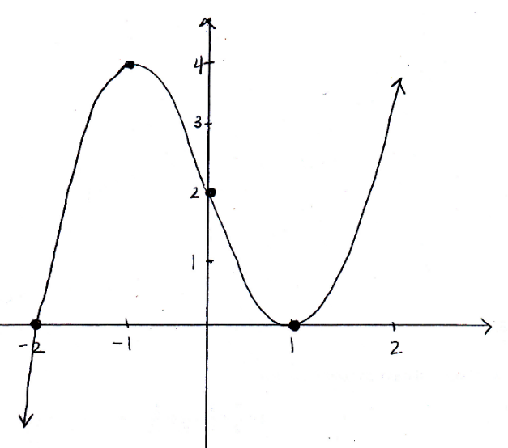

Example 9:
Sketch a possible graph of a function $f$ that satisfies the following conditions:
- on and on
- on and on
- and

First Derivative:
$$1$$
$$+$$
$$-$$
$$MAX$$
Increasing on:
Decreasing on:

Second Derivative:
$$-2$$
$$+$$
$$-$$
$$+$$
$$2$$

Concavity:  Concave up on:  Concave down on: | Inflection Points:  Occur at

